DATA CLEANING AND VISUALIZATION PROJECT REPORT
- Title
Data Cleaning and Visualization of Iris Dataset Using Python
- Objective
The main objective of this project is to perform data cleaning and visualization on the Iris dataset to identify patterns, verify data quality, and gain insights into the distribution of different Iris flower species.
- Introduction
Data cleaning is an important step in data analysis that ensures data quality by handling missing values, duplicates, and inconsistencies. Visualization helps in understanding the distribution and characteristics of data through graphical representation.
In this project, the Iris dataset was analyzed using Python libraries such as Pandas and Matplotlib.
- Dataset Description
The Iris dataset contains information about three species of Iris flowers:
- Iris-setosa
- Iris-versicolor
- Iris-virginica
The dataset consists of 150 records and 6 attributes:
- Id
- SepalLengthCm
- SepalWidthCm
- PetalLengthCm
- PetalWidthCm
- Species
- Tools and Technologies Used
- Python
- Pandas
- Matplotlib
- Google Colab
- Data Cleaning Process
Step 1: Loading the Dataset
The dataset was loaded into a Pandas DataFrame.
Step 2: Checking Missing Values
Missing values were checked using:
df.isnull().sum()
- Result
All columns contained 0 missing values.
Column | Missing Values
Id | 0
SepalLengthCm | 0
SepalWidthCm | 0
PetalLengthCm | 0
PetalWidthCm | 0
Species | 0
Step 3: Dataset Information
The dataset information showed:
- Total Records: 150
- Total Columns: 6
- Numeric Columns: 5
- Categorical Columns: 1
- Memory Usage: 7.2 KB
Step 4: Duplicate Handling
Duplicate records were checked and removed if present using:
df.drop_duplicates()
- Data Visualization
Graph 1: Count of Iris Species
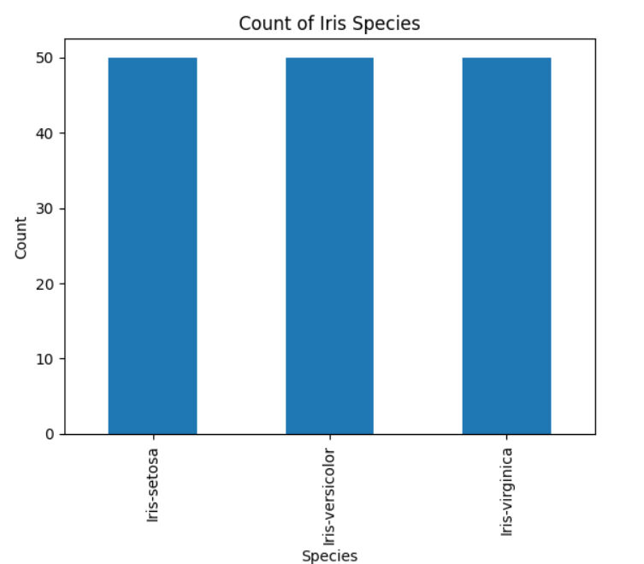
A bar chart was generated to visualize the number of flowers belonging to each species.
- Observation
- Iris-setosa = 50 samples
- Iris-versicolor = 50 samples
- Iris-virginica = 50 samples
The dataset is perfectly balanced because each species contains an equal number of observations.
- Output Analysis
- No missing values were found in the dataset.
- The dataset is clean and suitable for analysis.
- All three species have equal representation.
- The balanced dataset helps avoid bias in future machine learning models.
- Visualization clearly shows equal distribution among species.
- Results
- Successfully loaded and analyzed the Iris dataset.
- Verified data quality.
- Removed duplicate records.
- Generated meaningful insights from the dataset.
- Conclusion
The Iris dataset was successfully cleaned and visualized using Python. The dataset contained no missing values and had a balanced distribution of species. Data visualization helped in understanding the composition of the dataset and confirmed that all species were equally represented. This project provided practical experience in data preprocessing and exploratory data analysis.
- References
- Iris Dataset (Kaggle)
- Pandas Documentation
- Matplotlib Documentation
- Python Documentation

